

Subject:- CSE523 Machine Learning

**Weekly Report 5**

**Section-1**

Submitted to faculty: Prof. Mehul Raval

Date of Submission: 25-3-2023

**Student Details**

| Roll No. | Name of the Student | Name of the Program |
| --- | --- | --- |
| AU2040122 | Aditi Vasa | Btech CSE |
| AU2040002 | Shrey Somani | Btech CSE |
| AU2040196 | Vandan Shah | Btech CSE |
| AU2040048 | Ronit Shah | Btech CSE |

For this week our goal was to try different classifiers other than logistic regression to see if we could get better results and accuracy in the prediction.

Random Forest Classifier

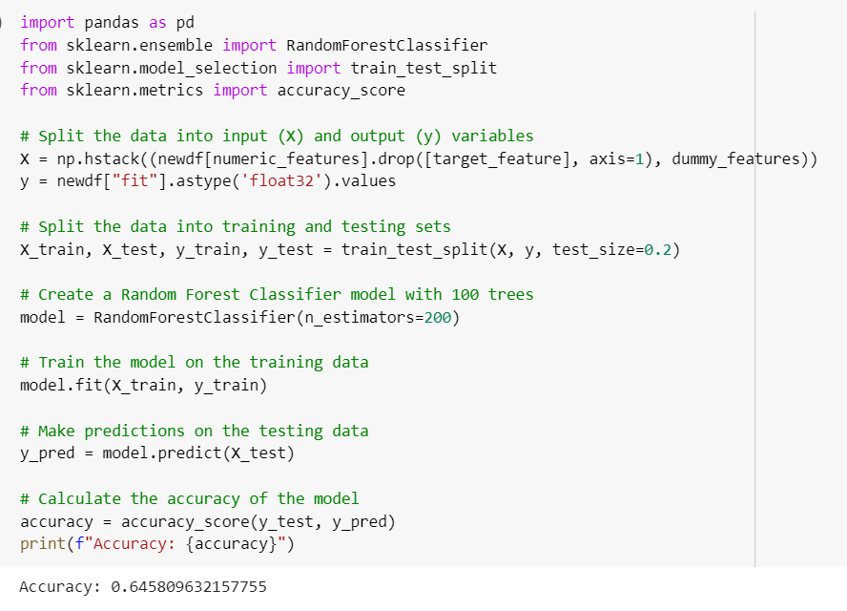

We tried random forest classifier by creating a model of 100 trees. The accuracy of the classifier is 64%.

K Nearest Neighbours

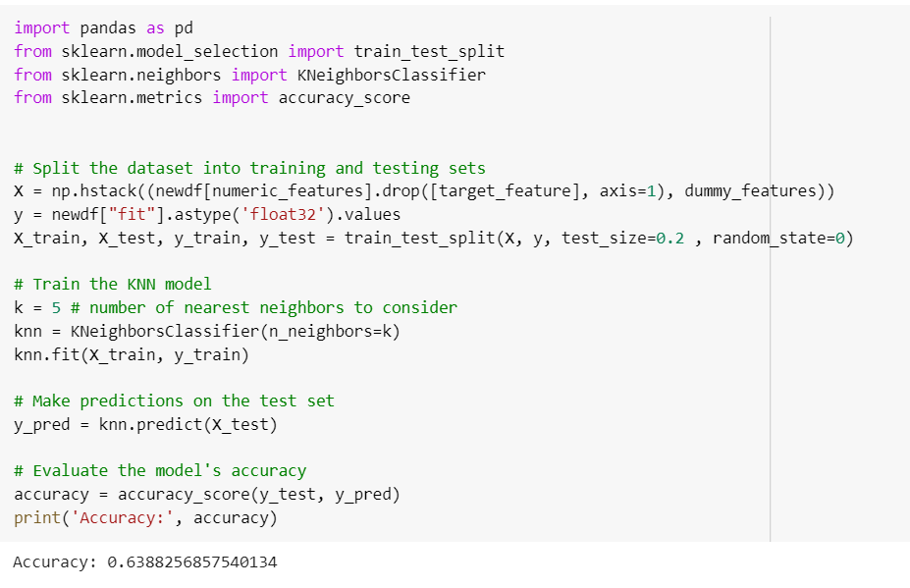

We tried k-NN classification, which is the best algorithm for clustering. The k we tried was five, which didn’t result in better results so we might try for different values of k.

Goals for next week:-

* Measure prediction accuracies for different values of k and implement confusion matrix.
* Define quadratic decision boundaries.